ICE SAILING MANUAL (lühendanud ja tõlkinud M. Veessaar)
For Ice Optimist and DN sailors
Support for leaders and beginners

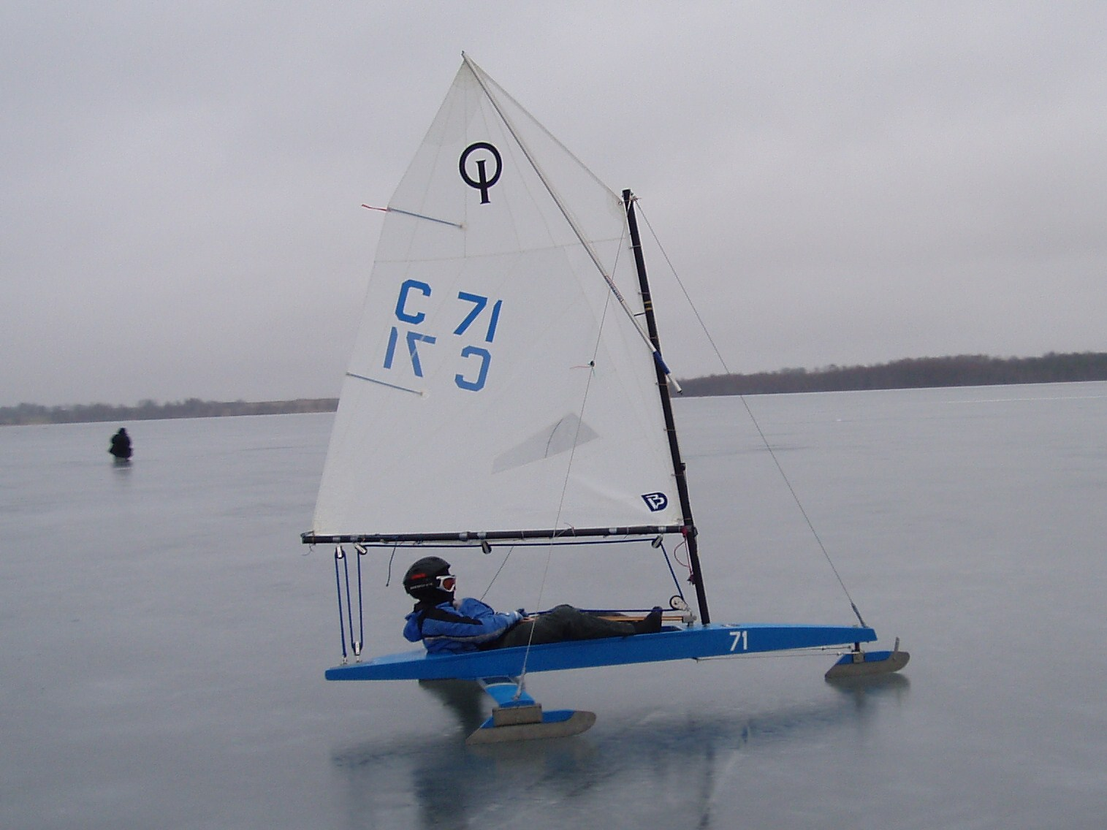

HISTORY
Ice sailing on skates or with Ice Yacht As long as there have been skates, sail and wind, people have been sailing on ice. Ice Yacht sailing was mentioned in year 1500-hundred, but it is probably much older. To race with the yacht, they waited to end of the 1800-hundred. Originally they were sailing in The Netherlands and Scandinavia. The modern Ice Yacht was developed in North America. The DN Ice Yacht was formed in North America 1937. The DN Ice Yacht is sailed by one man. The sail measures 6.25 square meters.
The first youth ice yacht with optimist sail was built in Estonia, and was sailed the first time in 1978. At the National secretary meeting 2002 in Balatonfured, the youth ice yacht got a standard and a name: Ice Optimist. The sail measures 3.25 square meters and could be the same as optimist summer sail boat. That is a result of good work in the junior program. Experienced ice sailors from Estonia Poland Great Britain Latvia Lithuania Russia Belarus and Sweden are developing young sailing on ice in a network.
The XV-Yacht is sailed by two men, one is steering and one is taking care of the sheet. The sail measures 15 square meters.
The Kitewing is the newest skate sail. It is an all-round sail that can be used with regular skates, skis or snowboard. An attractive sail among young sailors, easy to sail and to bring with you in a bag.

Safe thinking when you place the yacht on ice
NEVER GO OUT ALONE ON ICE.
ICE SHOULD BE CHECKED.
WEAR HELMET, SPIKES AND SHOES WITH SPIKES.
WEAR LIFE JACKET ON, OR IN YACHT.
Check what direction the wind comes from.
Place the yacht with steering runner into the wind with the parking brake engaged.
Be observant because the wind can change direction fast.
In strong wind, loosen the rear blocks from fuselage, or pull out the sheet.
Take the sail down and roll it up.
Keep a suitable distance from other parked yachts.
Never leave a yacht with sail without control, someone that does not know how could go out and try to test sailing the yacht. The yacht could also tip over and hurt someone.
When sailing, always keeping the FEET IN THE FUSELAGE, NEVER OUT AND IN FRONT OF THE PLANK

Hints for Trim
Sail
Flat sail to be used in hard wind.
Deep sail in light wind.
Storm sail that has less surface, and is to be used in heavy wind.
Sail with more depth for beginners.
The first sail can be a used summer sail in Ice Optimist class.
Runners
Short runners when snow on ice or light wind, they are easier to manoeuvre without losing speed.
Long runners at good wind and good ice. The yacht runs smoother with a long running surface.

Ice Yacht sailing countries letter marks
DN Yacht should have a 25 cm high country mark and registration number on both sides of sail. Ice Optimist should have an 8-10 cm high country mark and registration number on the side of fuselage at mast step level. At a race the sail should have the disc and optimist logotype. Commercials are not allowed on sail
B Belarus  C Estonia  CZ Czech Republic  D Denmark  G Germany  H Netherlands  I Italy  K United Kingdom  L Finland  M Hungary | N Norway  O Latvia  OE Austria  P Poland  R Russia  S Sweden  T Lithuania  Z Switzerland  US USA  KC Canada
Time to sail on ice!
Fold up the parking brake.
Keep the side stays loose in the beginning, later you can adjust them.
Figure out what direction the wind comes from.
Place you self on the same side where the wind comes in from.
Take the sheet in the hand you are holding the side stay and the other hand on the tiller.
Or if you prefer sheet and tiller in one hand and side stay in the other.
Push the yacht forwards, fall off the wind a little and let the wind help you to fill the sail and push the yacht.
Step up on the plank with one foot and slide the other foot into the fuselage and sit down or lay down.
Try to pull the sheet and tighten the sail, and steer up towards wind alternately fall off with the wind.
To stop the yacht you sail into the eye of wind. Nose pointing up towards wind.
You are tacking up against the wind and you are sailing with the wind reaching.
In half wind, the wind is coming in right from the side.

Training practice, suggestions for some exercises
Area of ice should have been checked before.
Area should be marked with flags, no other sailors than beginners are allowed in that area.
It is important to learn to sail the yacht safely, in the first practice on ice you should learn how to stop the yacht.
How to stop when the wind is coming towards you.
Line up the sailors with safe distance between them, so they do not sail into each other.
Place a mark or another leader ca 150 meters up towards wind.
Start them one at a time and let them sail up to the wind mark/leader and stop there up against the wind.
Let them try to start on both starboard and port tacks.
To stop when the wind is coming in from behind.
You can place a third mark in the middle to the left.
Place a mark/leader ca 150 meters down leeward.
Line up the sailors with safe distance between them.
Start them one at the time.
Let them sail down to the leeward mark .
Let them sail around the mark coming in from the left side and stop on the right side of the leeward mark up against the wind.
To stop when the wind is coming in from the side.
Place a flag/leader ca 100 meters out from the leeward mark on both sides.
Let the sailors try both with wind coming in port side and from starboard side.
They should round the flag/leader and stop up against the wind.
If there is snow on the ice and you have access to a plough, make a round track.
You can also make a round track with flags.It is enough with only 50 meters radius in the beginning. Place you self in the middle and give instructions.
Sail instruction for ice Optimist
Start
Line up on the start line with a slight angle towards wind – the sail not too hard home sheeted. ( Leeward runner against start number )
Run as fast as possible.
Jump into yacht when you have built up speed.
Fall off if possible to get good wind into the sail ( watch out so you do not sail into the yacht that is in the lee of you )
Sheet home with care.
Carefully steer up towards wind and try to find the right angle ( as high as possible, with the sail “pulling” all the time.
If you have been starting with the wind in from starboard side:
Tack when you are up 2/3 against the windward mark
Tack again when you estimate that you are able to sail around the windward mark.
If you have been starting with the wind in from port side:
Keep on sailing until you estimate that you can sail around the windward mark
and tack Sail around the windward mark with almost full sheet and keep the wind coming in from behind on the starboard (right) side Keep on sailing that way until you estimate that you can steer to the right of the leeward mark
Jibe so that the wind is coming in from behind on port (left) side
Sheet almost full. When you feel that the yacht could not sail any faster, loosen the sheet up to catch the wind again.
Sail around the mark so that you have it on the left side of you
Now you have been sailing one round, and you go on the same way the remaining rounds.
Finish
Finish by crossing the finishing line and turning right or left.
Finish line is a line between leeward mark and flag to the right.
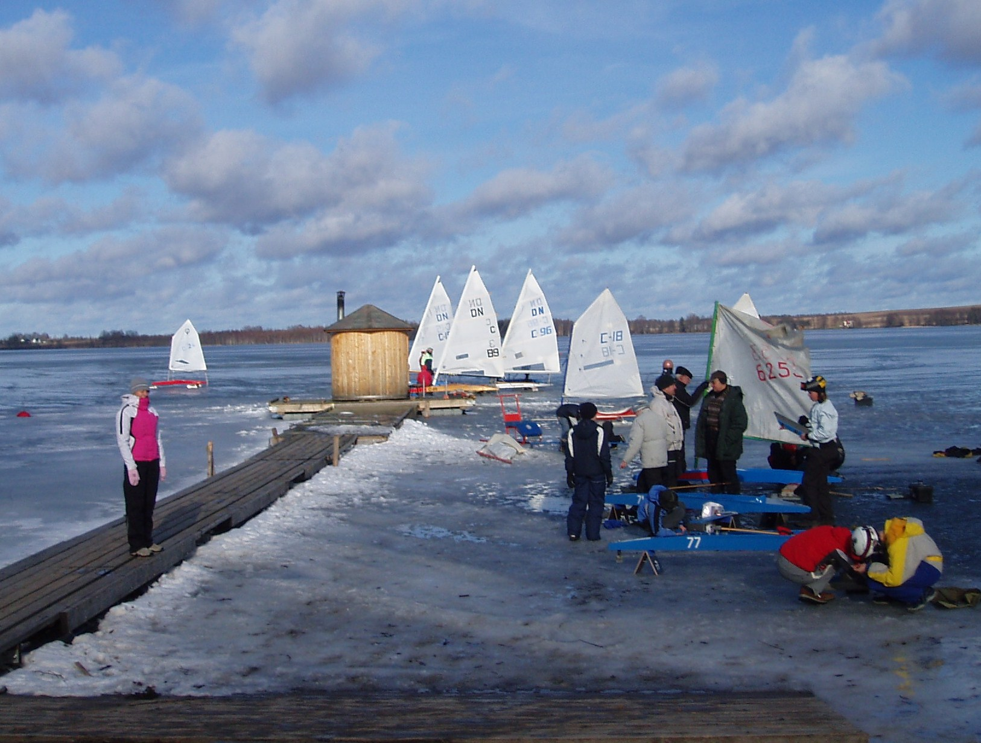
Sail to the depot right after finish!!!!!!!!. You must go round the left or right end of starting line to get to the depot. If you cross the starting line with your runners, you will be disqualified, and that can damage your runners.
PART 1 – DEFINITIONS
When one of the terms defined in part 1 is used in its defined sense in the definitions or rules, it is printed in CAPITAL LETTERS. All definitions rank as rules.
ACTUAL WIND – The natural wind
WINDWARD - LEEWARD COURSE – A course sailed around two MARKS, an imaginary strait line drawn between the two MARKS is parallel to the ACTUAL WIND.
ON – THE – WIND- A yacht heading less than 90 degrees from the direction from which the ACTUAL WIND is blowing is ON – THE – WIND.
OFF – THE – WIND – A yacht heading more than 90 degrees from the direction from which the ACTUAL WIND is blowing is OFF – THE – WIND.
STARBOARD TACK – A yacht is on STARBOARD TACK when the ACTUAL WIND is approaching from her right side.
PORT TACK – A yacht is on PORT TACK when the ACTUAL WIND is approaching from her left side.
WINDWARD YACHT and LEEWARD YACHT – When two yachts are on the same tack, the one on the side from which the ACTUAL WIND is blowing is the WINDWARD YACHT, the other is the LEEWARD YACHT.
TACKING – A yacht is TACKING from the moment she is beyond head-to-ACTUAL WIND until her mainsail has filled on the other side.
JIBING – A yacht is JIBING when, the ACTUAL WIND aft, the foot of her mainsail crosses her centreline until it has filled on the other side.
OBSTRUCTION – Any object a yacht cannot safely sail over.
MARK – Any object which a yacht must round or pass on a required side to properly round the course.
OUTSIDE – In rule 8 of the Right-of Way rules, any yacht to the right of another yacht is the OUTSIDE yacht.
CANCELLATION – A CANCELLED race is one which cannot thereafter be sailed.
POSTPONEMENT – A POSTPONED race is one which is not started at it’s scheduled time and which can be sailed at any time the Race Committee may direct.
ABANDONMENT – An ABANDONED race is one which is stopped while it is in progress and which can be re-sailed at the discretion of the race committee.
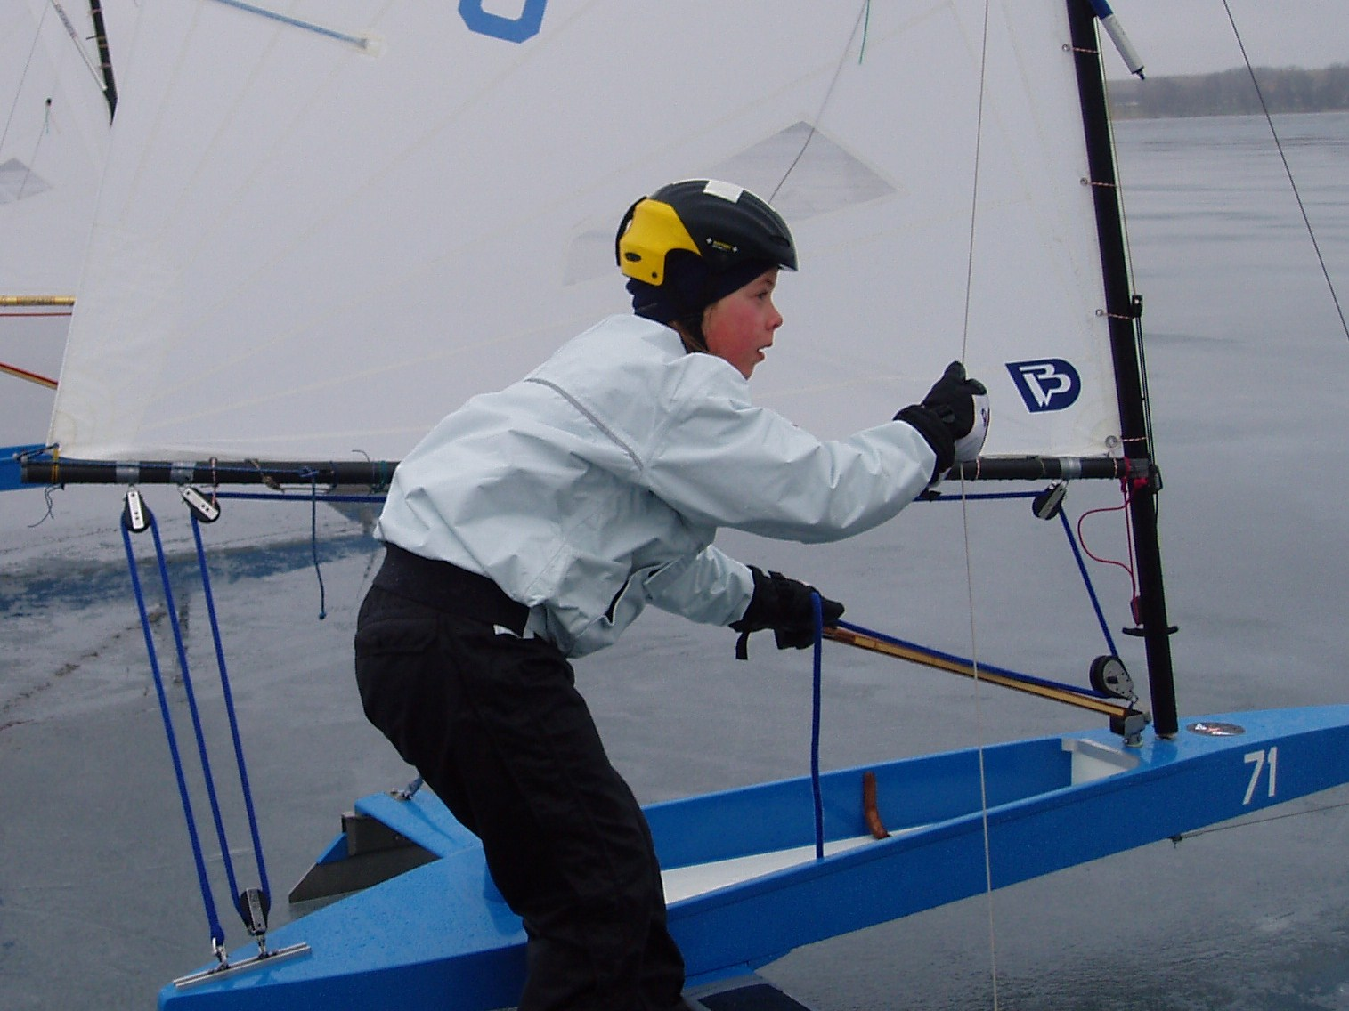
PART lV – SAILING RULES
The purpose of the following rules is to prevent collisions. Any infraction of these rules is cause for disqualification.
A.Fair Sailing – In all situations the Judges, Race Committee, and contestants must act in terms of common sense, safety, and good sportsmanship.
B.Right – of Way Rules
1.A yacht in motion shall keep clear of yacht stopped.
2.A Yacht sailing OFF-THE-WIND shall keep clear of a yacht sailing ON-THE WIND.
3.When two yachts are sailing OFF-THE-WIND, the yacht on the PORT TACK shall keep clear of the yacht on the STARBOARD TACK.
4.When two yachts are sailing OFF-THE-WIND, the yacht on the PORT TACK shall keep clear of the yacht on the STARBOARD TACK. When two yachts sailing ON-THE-WIND are on the same tack, the WINDWARD YACHT shall keep clear. When two yachts sailing OFF-THE-WIND are on the same tack, the LEEWARD YACHT shall keep clear.
5.A right-of-way yacht shall not alter her course so as to mislead or prevent a non-right-ofway yacht from keeping clear. When a faster moving yacht approaches another yacht on the same tack from the rear, the faster yacht must not sail so close that the slower cannot keep clear.
6.A yacht may not TACK or JIBE so as to involve the probability of collision with another yacht which, owing to her position or speed, cannot keep clear.
7.A yacht approaching and unable to clear an OBSTRUCTION with out fouling or endangering another yacht may signal the other yacht for room to clear. The signalled yacht shall at once give room and if it is necessary for her to TACK or JIBE, the signalling yacht shall also TACK or JIBE immediately thereafter.
8.When approaching or rounding a MARK, an OUTSIDE yacht shall keep clear and faster moving yacht approaching another yacht from the rear shall stay clear of a yacht that has started her rounding manoeuvre. Each yacht shall be entitled to room to cross the finish line.
9.After finishing a race, a yacht shall keep clear of the course and yachts still racing.
C.Sailing the Course
1. At the start, a yacht must be laid off (headed) similarly to other yachts on the line. A skipper may demand that the race committee require another yacht to change the degree to which she is laid off.
2. A Yacht shall be disqualified without protest if she starts prematurely.
3. A yacht fouling a MARK (except when avoiding an accident), not leaving a MARK on the required side, or not rounding all MARKS in proper sequence, shall be disqualified.
D.Propulsion – A yacht may not employ any means of propulsion other than the action of the wind on the sails. However, the crew (unassisted by anyone except for reasons of physical disability as authorized by the Judges) may push the yacht to leave the starting line or to return the yacht to wind propulsion when necessary. Other pushing shall be cause for disqualification.
E.Ballast – A Yacht must start and finish a race with the same ballast and crew.
Be observant that the instructions and the rules may change.

NIA jääpurjetamise reeglid. Võistlusmäärused.

A – AUS PURJETAMINE
Jääl purjetades peab jälgima turvalisust, tervet mõistust ja sportlikku vaimu.
B – VÄLTIMISREEGLID
- Liikuv kelk hoiab seisvast kelgust eemale.
- ERINEV TAVAPURJETAMISEST - Alltuule sõitev kelk annab teed tihttuules sõitvale kelgule. Ehk krüssaval kelgul on alati teeõigus.
- Kui kelgud sõidavad samal halsil tihttuules või mõlemad alltuules, siis vasakul halsil sõitev kelk peab teed andma paremal halsil sõitvale kelgule.
- Kui mõlemad kelgud sõidavad tihttuules, siis pealtuule sõitev kelk annab teed alltuule sõitvale kelgule. ERINEV TAVAPURJETAMISEST – Allatuult sõitvate kelkude puhul on pealtuule sõitval kelgul õigus.
- Kelk, millel on teeõigus, ei tohi muuta oma kurssi nii, et see segaks teedandva kelgu tegevust. Kui kiirem kelk läheneb samal halsil sõitvale aeglasemale kelgule, on ta kohustatud aeglasemast kelgust piisavalt kaugelt mööduma, et teda mitte segada.
- Kelk ei tohi pautida ega halssida nii, et tekib teiste kelkudega kokkupõrkeoht sedasi, et nad ei suuda oma koha või kiiruse tõttu kokkupõrget vältida.
- Juhul kui kelk on lähenemas jääl olevale takistusele, millest ei ole võimalik kokkupõrkeohuta mööduda, tuleb teistele kelkudele märku anda. Märguannet märgates peab teeõigust omav kelk viivitamatult luhvama-vallama, pautima-halssima, et anda teed takistusest möödumiseks.
- Kui kaks kelku on jõudnud üheaegselt märgini sellest möödumiseks, peab märgi suhtes välimine kelk andma teed sisemisele kelgule. ERINEV TAVAPURJETAMISEST – kõigil kelkudel peab olema ruumi finishiliini ületamiseks.
- Peale finisheerimist annab kelk teed veel võistlevatele kelkudele ning hoiab eemale võistlusrajast.
C – RAJAL PURJETAMINE
- Starti minnes peavad olema kõik kelgud ühe nurga all.
- Valestardi puhul kohe DSQ
- Märgi puudutades, märki vahele jättes või valelt poolt märki sõites kohe DSQ
D – KELGU LIIKUMA SAAMINE
Kelku tohib käima joosta ainult stardis.
E – BALLAST
Kelk peab starima ja finisheerima sama ballastiga ning meeskonnaga.
